MASTER ART WORKSHOPS - Programme 2024
Many of our workshops are suitable for beginners, some of our artists supply all materials.
Workshops will be added throughout the year so keep checking on
www.masterartworkshops.com for dates, times and prices

At Little Berkhamsted Village Hall: Little Berkhamsted Lane, Herts SG13 8LU
At Epping Golf Course: Flux’s Lane, Epping, Essex CM16 7PE
At Dutch Marketplace: Great North Road, Hatfield AL9 6ND

Sunday 11th February – Epping. Gel Printing with Holly Casey, 10-1pm £50
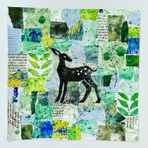
Sunday 17th March - Epping
Mandala Dotting with Angelique Samadhi 10-1pm £50

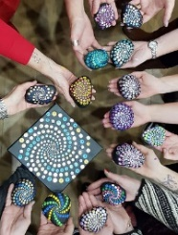

Saturday 23rd March – Dutch Marketplace, Spring Flowers Watercolour with Deana Kim Page 10-1pm £55 inc lunch

Saturday 6th April – Little Berkhamsted
Landscape in Watercolours with Frank Walters 10-4pm £90
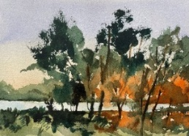

Saturday 13th April – Little Berkhamsted, Mixed Media with Sera Knight 10-4pm £85
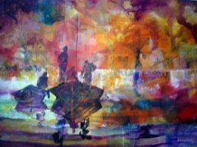
Sunday 19th May - Epping
Flamingos in Acrylics with Phillippa Gunn 10-1pm £50
Tuesday 21st May - Little Berkhamsted
Floral Watercolours with Nicky Hunter 10-4pm £85

Sunday 26th May - Epping
Ceramic Dream catchers with Judith Annakie-Erikson 10-1pm £50

Wednesday 12th June – Little Berkhamsted
Lino Cutting with Jackie Devereux 10-4pm £85
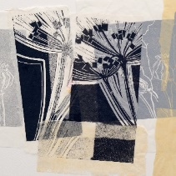

Saturday 22nd June – Little Berkhamsted
Watercolours with Jake Winkle
10-4pm £90
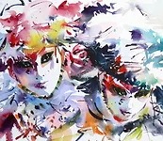
Saturday 6th July, Sunday 7th July – Little Berkhamsted
Watercolours ‘En Plein Air’
Barry Herniman
Sat 10-4pm £85
Sun 10-1pm £55
Both Workshops £125

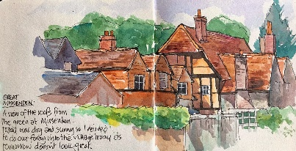

Saturday 20th July – Dutch Marketplace
Pastels with Deana Kim Page
10-1pm £55

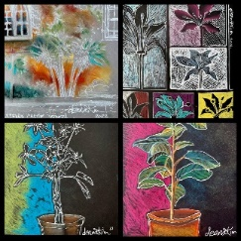

Sunday 22nd September - Epping
Acrylics with Phillippa Gunn 10-1pm £50

Saturday 28th September – Little Berkhamsted
Return of Jake Winkle Watercolours
10-1pm £85

Saturday 19th October – Little Berkhamsted, Candle Making with Anne Nudd 10-1pm £65
Wednesday 6th November – Little Berkhamsted
Birds in Watercolours with Nicky Hunter
10-4pm £85
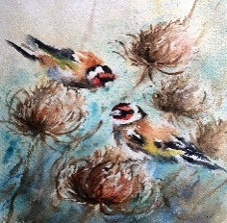

Sunday 10th November – Epping
Create Mosaic Stars with Nicola Upton 10-1pm £65

