MASTER ART WORKSHOPS
2026 Workshops
To book your favourite workshop email us at www.masterartworkshops.com or suewilliams021@aol.com

Please note - This is our draft programme, prices and dates may change

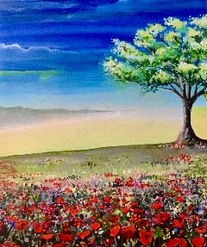 | Saturday 28th March at Little Berkhamsted  Acrylics with Deana Kim Page  10am - 1pm price £50 includes all materials and refreshments, suitable for all levels
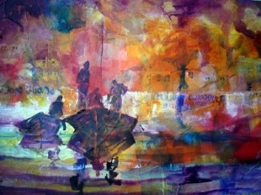 | Saturday 11th April at Little Berkhamsted  Mixed Media with Sera Knight  10am – 4pm price £90 some materials and lunch included, suitable for all levels
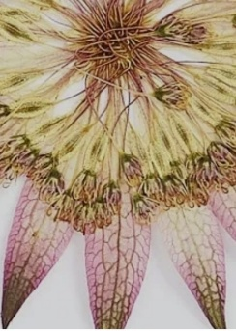 | Saturday 25th April at Dutch Marketplace  Pressed Flower Art Cards with Lis Moon  10am -1pm price £65 all materials and lunch included, suitable for all levels
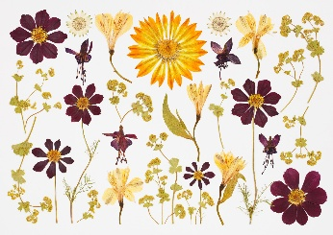 | Saturday 30th May at Dutch Marketplace  Pressed Flower Art Cards with Lis Moon  10am -1pm price £65 all materials and lunch included, suitable for all levels
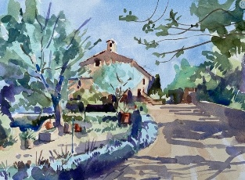 | Saturday 27th June at Little Berkhamsted  Landscape Watercolours with Frank Walters  10am -4pm price £90 lunch included, suitable for all levels
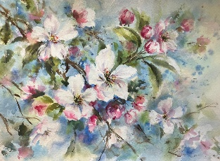 | Saturday 11th July at Little Berkhamsted  Floral Watercolours with Nicky Hunter  10am - 4pm price £90 lunch included, some experience required
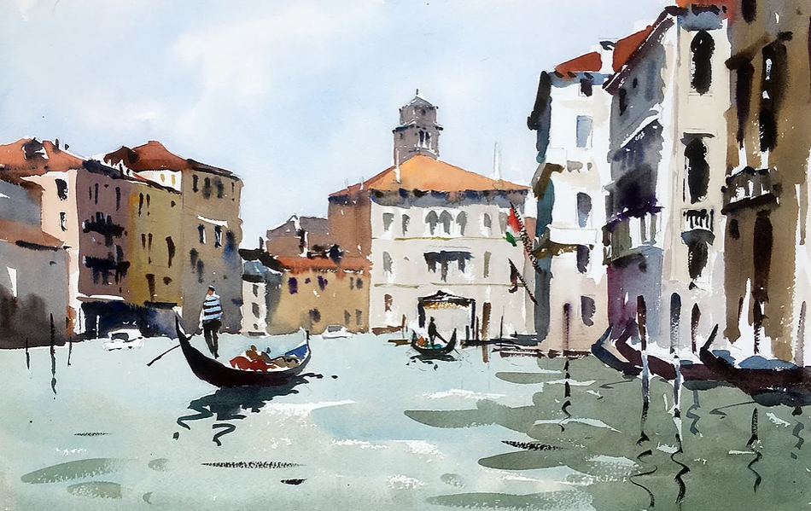 | Saturday 22nd August at Little Berkhamsted  Watercolours with Jake Winkle  10am - 4pm price £90 lunch included, suitable for all levels
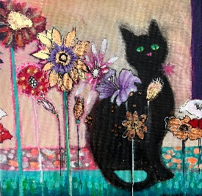 | Saturday 19th September at Little Berkhamsted  Acylics with Deana Kim Page  10am - 1pm price £50 all materials included, suitable for all levels
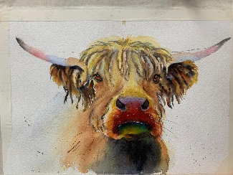 | Saturday 3rd October at Little Berkhamsted  Watercolours with Jake Winkle  10am – 4pm price £90, lunch included, suitable for all levels
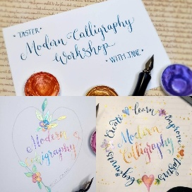 | Saturday 17th October at Little Berkhamsted  Calligraphy with Jane Lappage  10am - 4pm price £90 lunch included, suitable for all levels
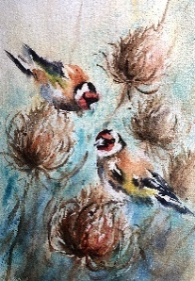 | Saturday 7th November at Little Berkhamsted  Watercolours with Nicky Hunter  10am - 4pm price £90 lunch included, some experience required

These images are a sample of the artist’s work and a more specific image will be circulated prior to the workshop where possible.

Our full day workshops include a two course lunch, with tea and coffee available all day. Half day workshops include welcome refreshments & cake
- Little Berkhamsted workshops take place at Little Berkhamsted Village Hall, SG13 8LY.
- Dutch Marketplace is at Great North Road, Hatfield AL9 6ND

We look forward to seeing you soon.

Kind regards
Sue and Judith

Follow us on social media to keep up with our news -
Facebook page is
http://www.facebook.com/masterartworkshops
and Instagram page is @masterartworkshops

